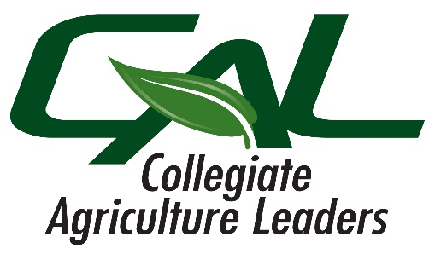

**Collegiate Agricultural Leaders**

**Spring Leadership Competitions**

*February 28th, 2025 @ Modesto Junior College*

Schedule: ACE Pavilion on MJC West Campus

12:00pm Welcome & Contest Overview

Turn in portfolios - Judged during the day

12:30pm Begin Leadership Competitions

* Extemporaneous Public Speaking
* Ag Sales - with a marketing twist
* Ag Education Presentations - New this year
* Job Interview:
  + Ag Education
  + Horticulture & Natural Resources
  + Production Agriculture
  + Ag Technician
  + Ag Sales & Service

3:30pm College Bowl Orientation

4:00pm College Bowl (Preliminary & Semi-Final Rounds)

6:00pm Dinner

6:30pm College Bowl Finals

7:00pm Awards